# Brainstorm

## Before you collaborate

##### A little bit of preparation goes a long way with this session. Here’s what you need to do to get going.

###### 10 minutes

**1**

## Define your problem statement

##### Visualizing and Predicting Heart diseases with an interactive dashboard

###### 5 minutes

**2**

## Brainstorm

##### Write down any ideas that come to mind that address Visualizing and Predicting Heart Diseases

###### 10 minutes

**TIP**

You can select a sticky note and hit the pencil [switch to sketch] icon to start drawing!

**3**

## Group ideas

##### Take turns sharing your ideas while clustering similar or related notes as you go. Once all sticky notes have been grouped, give each cluster a sentence-like label. If a cluster is bigger than six sticky notes, try and see if you and break it up into smaller sub-groups.

###### 20 minutes

**4**

## Prioritize

##### Your team should all be on the same page about what's important moving forward. Place your ideas on this grid to determine which ideas are important and which are feasible.

**20 minutes**

## After you collaborate

You can export the mural as an image or pdf to share with members of your company who might find it helpful.

**Quick add-ons**

# & idea prioritization

**PROBLEM**

**How might we Visualize and Predict heart disease with an interactive dashboard?**

**A Team gathering**

Define who should participate in the session and send an

Anbarasi mariyapushbam J

**TIP**

Add customizable tags to sticky notes to make it easier to find, browse, organize, and categorize important ideas as themes within your mural.

**Gayathri k**

Boomika I

**Jelciya M**

1. **Share the mural**

Brainstroming and ideation for Visualization and Prediction of

invite. Share relevant information or pre-work ahead.

1. Set the goal

Good pulse Stress free

Gentle

rate

Laugh therapy

Caring

Proper checkup

Less

Know about Heart

Keep track

Regular checkups

Early wake

Long distance maintenance

Reliable

Good environment

Qualiity

Diet maintenance

Less usage

Good food

Knowlege

Security emergencies

More data

Yoga practics

Don't get

**Share a view link** to the mural with stakeholders to keep them in the loop about the outcomes of the session.

### Heart Diseases

Think about the problem you'll be focusing on solving in

the brainstorming session.

1. Learn how to use the facilitation tools

Use the Facilitation Superpowers to run a happy and

noise

Tolerance of pain

Melodies

Minor pain

relatives

Take medicines

complications

Bearable

on strokes

Daily routine

up

Regular visit to doctors

neighbours

Independent

over

quantity

Less tension

of

electronics

Less complications

Complicated

Lead normal life

Lead normal life

too excited

Enjoyment is not ended

**B Export the mural**

Export a copy of the mural as a PNG or PDF to attach to emails, include in slides, or save in your drive.

**10 minutes** to prepare **1 hour** to collaborate **4 people**

productive session.

[**Open article**](https://support.mural.co/en/articles/2113740-facilitation-superpowers)

**Key rules of brainstorming**

Qualiity over quantity

Yoga practics

To run an smooth and productive session

#### Keep moving forward

Strategy blueprint

Define the components of a new idea or strategy.

[Open the template](https://app.mural.co/template/e95f612a-f72a-4772-bc48-545aaa04e0c9/984865a6-0a96-4472-a48d-47639307b3ca)

**Customer experience journey map**

Stay in topic. Defer judgment.

Encourage wild ideas. Listen to others.

#### Importance

If each of these

Understand customer needs, motivations, and obstacles for an experience.

[Open the template](https://app.mural.co/template/b7114010-3a67-4d63-a51d-6f2cedc9633f/c1b465ab-57af-4624-8faf-ebb312edc0eb)

Know about Heart

Go for volume. If possible, be visual.

tasks could get

done without any difficulty or cost, which would have the most positive impact?

Strengths, weaknesses, opportunities & threats

Identify strengths, weaknesses, opportunities, and threats (SWOT) to develop a plan.

|  |  |
| --- | --- |
|  |  |
|  |  |

[Open the template](https://app.mural.co/template/6a062671-89ee-4b76-9409-2603d8b098be/ca270343-1d54-4952-9d8c-fbc303ffd0f2)

Melodies

**TIP**

Participants can use their cursors to point at where sticky notes should go on the grid. The facilitator can confirm the spot by using the laser pointer holding the **H key** on the keyboard.

[Share template feedback](https://muralco.typeform.com/to/CiqaHVat?typeform-source=app.mural.co)

[**Share template feedback**](https://muralco.typeform.com/to/CiqaHVat?typeform-source=app.mural.co)

#### Feasibility

Regardless of their importance, which tasks are more feasible than others? (Cost, time, effort, complexity, etc.)

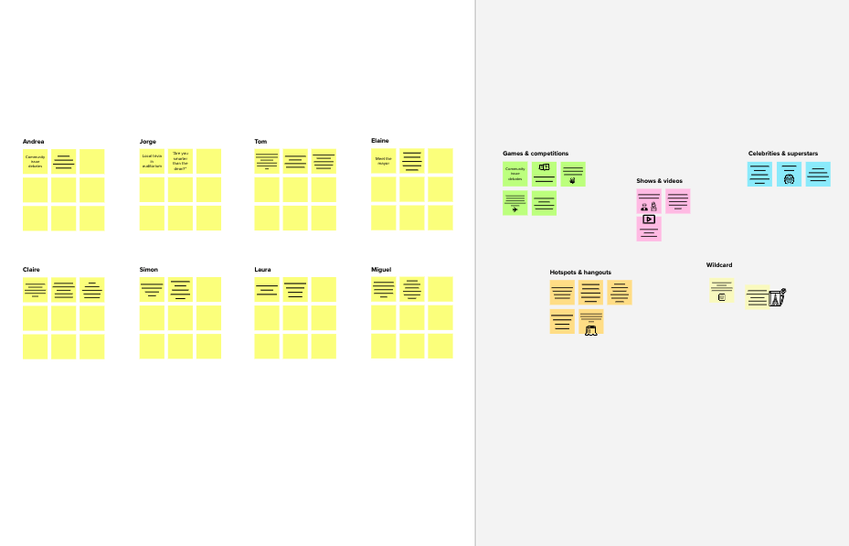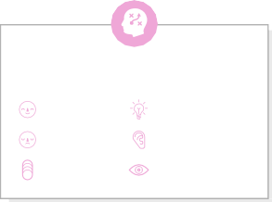

**Template**

**Need some inspiration?**

See a finished version of this template to kickstart your work.

[**Open example**](https://app.mural.co/template/e5a93b7b-49f2-48c9-afd7-a635d860eba6/93f1b98d-b2d2-4695-8e85-7e9c0d2fd9b9)